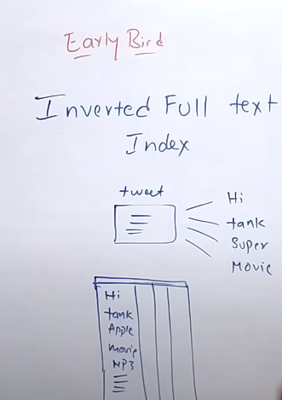

Tweet is broken into words

These words are then stored into tables

Mapping tweets that contain same or similar words